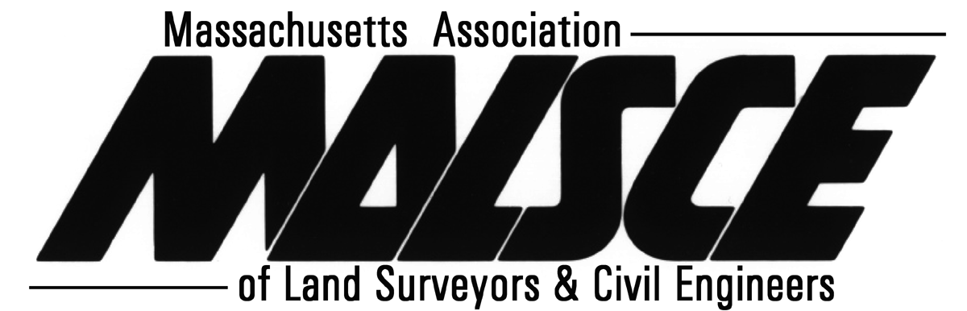

Become a 2019 MALSCE & NESS Convention Advertiser and Sponsor!

2019 MALSCE & NESS Convention Advertising and Sponsorship
March 14 & 15, 2019, DoubleTree by Hilton Hotel Leominster, 99 Erdman Way, Leominster, MA 01453

Promote your company’s products and/or services to 2019 MALSCE Convention attendees by taking advantage of the following advertising and sponsorship opportunities.

Convention Booklet Advertising:
Booklets including the 2019 MALSCE Convention schedule, exhibitor listings and session handouts will be printed prior to the convention and distributed to all attendees. Advertisers will have company name included in convention introduction powerpoint presentation. Advertisements must be submitted as black and white with the exception of cover page advertisements, which can be in full color. Please ensure these advertisements are high resolution (minimum 300 dpi) JPEG, TIFF or PDF files and received by March 4, 2019. The advertisement size and cost options are listed below:

Advertisement | Advertising Rates
 | MALSCE Sustaining Member Companies | Individual MALSCE Members* | Non-Members
1/8 page (Business Card)  Dimensions: 3.5” x 2” | $25.00 | $30.00 | $35.00
1/4 page  Dimensions: 8” x 2” | $75.00 | $90.00 | $100.00
1/2 page  Dimensions: 8” x 4” | $150.00 | $180.00 | $200.00
Full page (internal)  Dimensions: 8.5” x 11” | $225.00 | $270.00 | $300.00
Full page on inside front cover, inside back cover, back cover (can be in color)  Dimensions: 8.5” x 11” | $300.00 | $360.00 | $400.00
*Includes member employers

Convention Sponsorship:
Sponsors will have company logo included on a sign displayed at the buffet table in addition to company logo included in the convention sponsors powerpoint presentation and thanked at the beginning of the convention. The following refreshment break sponsorship options are not exclusive, so if you choose to do so, you can sponsor multiple breaks.

Function | Sponsorship Fee
Friday Breakfast/Mid-Morning Break | $75.00
Friday Luncheon | $150.00
Friday Dinner | $150.00
Saturday Breakfast/Mid-Morning Break | $75.00
Saturday Luncheon | $150.00

All advertisement files should be emailed to Emily Devane at edevane@engineers.org. Payment for the ad must accompany this registration form.

Please read, complete and return page 2 of this form – Page 1

MALSCE, One Walnut Street, Boston, MA 02108-3616; 617/227-5551 (T); 617/227-6783 (F); malsce@engineers.org; www.malsce.org

2019 MALSCE & NESS Convention Advertiser/Sponsor Registration Form
I would like to be a (please check one):

 |  |  | Advertiser |  | Sponsor |  |  |  | Both
Contact Name: |  |  |  |  |  | Contact Telephone:
Contact Email:
Organization:
Address:
City, State, Zip:
Convention Booklet Advertising (Please check all that apply)

Sustaining Member Companies Individual MALSCE Members Non-Members
 | 1/8 page ad - $25 |  |  | 1/8 page ad - $30 |  | 1/8 page ad - $35
 | 1/4 page ad - $75 |  |  | 1/4 page ad - $90 |  | 1/4 page ad - $100
 | 1/2 page ad- $150 |  |  | 1/2 page ad - $180 |  | 1/2 page ad - $200
 | Full page ad - $225 |  |  | Full page ad - $270 |  | Full page ad - $300
 | Full page inside front cover ad - $300 |  |  | Full page inside front cover ad - $360 |  | Full page inside front cover ad - $400
 | Full page inside back cover ad - $300 |  |  | Full page inside back cover ad - $360 |  | Full page inside back cover ad - $400
 | Full page back cover ad - $300 |  |  | Full page back cover ad - $360 |  | Full page back cover ad - $400
Convention Sponsorships (Please check all that apply)
 | Friday Breakfast/Mid-Morning Break - $75
 | Friday Luncheon - $150
 | Friday Dinner - $150
 | Saturday Breakfast/Mid-Morning Break - $75
 | Saturday Luncheon - $150
Registration Deadline: Monday, March 4, 2019. You can pay your convention advertising and/or sponsorship fees using Visa, MasterCard, American Express or a check made payable to “MALSCE”. Provide the information requested below if paying by credit card and submit via fax to 617/227-6783, or email to malsce@engineers.org. If paying by check, fax or email this form and mail your check to: MALSCE, One Walnut Street, Boston, MA 02108-3616. Please include a copy of this form with your check.
Total Amount Enclosed: $
Or Pay with (Check one): |  |  | Visa |  |  |  | Master Card |  |  |  | American Express
Card Name:
Card Number: |  |  |  |  |  |  |  | Expiration Date:
Billing Address:
City: |  |  |  |  | State: |  |  |  | Zip:
Signature:
- Advertising and Sponsorship registration is processed on a first-come, first-served basis.
- Registration deadline is Monday, March 4, 2019.
- Questions? Contact Rich Keenan at 617/305-4110 or Emily Devane at 617/305-4113

Please read, complete and return this form – Page 2

MALSCE, One Walnut Street, Boston, MA 02108-3616; 617/227-5551 (T); 617/227-6783 (F); malsce@engineers.org; www.malsce.org

