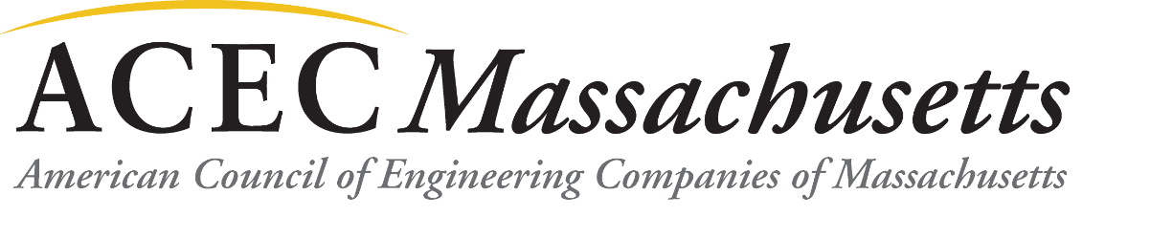
2019 ACEC/MA Corporate Sponsorship
Respond Now to Take Full Advantage of Programs starting in February 2019

The American Council of Engineering Companies of Massachusetts (ACEC/MA) is excited about the dynamic program of events planned for Calendar Year 2019. Members continue to report that attending these quality programs is of tremendous benefit to them. Based on the past outstanding participation in the Annual Corporate Sponsorship program, ACEC/MA is offering member firms the opportunity to become a 2019 ACEC/MA Corporate Sponsor by sponsoring several events with a single payment.

Becoming an ACEC/MA Corporate Sponsor provides member firms the convenience of one upfront payment to enjoy multiple advertising opportunities and registration benefits throughout the year--a significant package savings over sponsoring events individually. Additionally, sponsorship demonstrates your firm’s professional commitment to the vision of ACEC/MA: “To lead with our knowledge and expertise and to be the voice of the engineering industry for the benefit of society and the natural and built environment.”

ACEC/MA efforts include:
- Promoting the business interests of the engineering industry to Congress, federal agencies and international organizations;
- Supporting state legislation and policies that create a favorable business climate for engineering and land surveying companies;
- Promoting Qualifications Based Selection at all levels of public and private sector procurement; and
- Providing business practice resources and educational programs to the engineering and land surveying industry.

The 2019 Corporate Sponsorship package includes seven ACEC/MA monthly program events, tentatively set as follows:
February | Social Equity & Transportation Breakfast Program
March | Energy and Utilities Markets Half-Day Conference
April | State Markets Half-Day Morning Conference
June | Annual Celebration Special Event
September | Networking Reception/Technical Tour
October | Breakfast Program – TBA
November or December | Breakfast Program – TBA

ACEC/MA reserves the right to change topics and timing of programs. ACEC/MA may offer other programs not covered by this Corporate Sponsorship.

The specific advertising benefits and cost for Platinum, Gold and Silver Sponsorship levels are detailed on the next page. Note: the fee for each sponsorship level has remained the same since 2007.

Platinum Sponsor - $6,000
- Company name listed on promotional materials, event signage and announced at each monthly program event introduction.
- Company name and logo prominently shown on the ACEC/MA website: www.acecma.org
- Direct link from your logo on ACEC/MA website to your company’s website.
- Sponsorship highlighted in the ACEC/MA Insights Newsletter sent electronically to members approximately four times yearly.
- Sponsorship listed in the ACEC/Matters electronic news sent to members.
- Placement of promotional materials on each guest table/seat/seminar packet of materials or ability to display company board or ability to have promotional information at registration at monthly program events.
- Two complimentary admissions (includes the one seat at the head speaker table noted above) to each of the 7 monthly program/events.
- Special Bonus - Two complimentary admissions to the Engineering Excellence and Awards Gala on March 20, 2019.
- Approximate value of the complimentary admissions to the events and the Awards Gala is $1,200 in registration fees.

Gold Sponsor - $3,000
- Company name listed on monthly event promotional materials and event signage.
- Company name listed on ACEC/MA website: www.acecma.org.
- Sponsorship listed in the ACEC/Matters electronic news sent to members.
- Space at a shared information table at each monthly program event with other Gold sponsor(s) or ability to display company board.
- One complimentary admission to each of the seven monthly program events listed above.
- Approximate value of the complimentary admissions to the events is $500 in registration fees.

Silver Sponsor - $1,500
- Company name listed on event promotional materials and event signage.
- Company name listed on ACEC/MA website: www.acecma.org.
- Sponsorship listed in the ACEC/Matters electronic news sent to members.
- May place company promotional materials at/near the monthly program event registration table or ability to display company board.

To become a Corporate Sponsor, sign up by January 31, 2019 using the form enclosed. We greatly appreciate your continued support.

If you would prefer to sponsor individual events through Individual Program Sponsorship, contact Natalia Savatic, ACEC/MA The Engineering Center Education Trust: acecma@engineers.org or 617/227-5551.

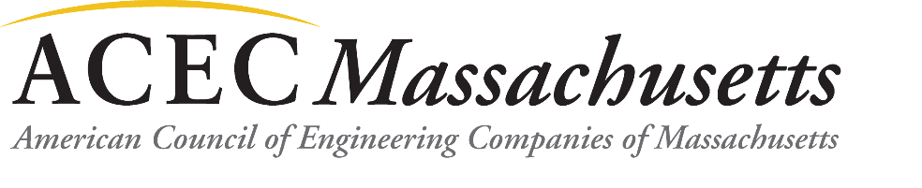

2019 ACEC/MA CORPORATE SPONSORSHIP SIGNUP FORM

Yes, I would like to be a Corporate Sponsor at the following level:

Desired Level of Sponsorship | Cost
Platinum | $6,000
Gold | $3,000
Silver | $1,500

Sign up by Thursday, January 31, 2019.

Firm/Organization Name:
(exactly as it should be listed on promotional materials and event signage)
Sponsor Key Contact:
Address:
Phone: ____________ Fax: _____________ Email:

Fax this form and Credit Card Payment information to ACEC/MA at 617/227-6783 or email the form to acecma@engineers.org.

Check one form of payment: MasterCard _____ Visa _____ American Express ______

Name on Card:
Billing Address:
Billing City/State/Zip:
Card #:
Exp Date:
Cardholder Signature:

OR
Make Checks payable to ACEC/MA and mail to: ACEC/MA, The Engineering Center, One Walnut St, Boston, MA 02108-3616
Email Address for Receipt: _______________________________________

