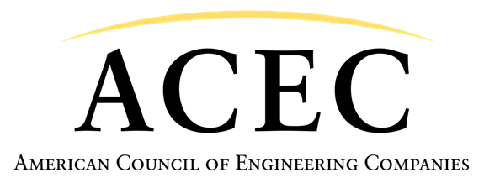

**PPP Loan Forgiveness**

**Purpose**

The American Council of Engineering Companies (ACEC) is seeking to clarify the treatment of loan forgiveness received by an engineering firm for a Paycheck Protection Program (PPP) loan relative to direct and indirect costs allocable to government contracts in accordance with Federal Acquisition Regulation (FAR) Part 31.

ACEC is the business association of the nation’s engineering industry. Founded in 1906, ACEC is a national federation of 52 state and regional organizations representing more than 5,600 engineering firms and 600,000+ engineers, surveyors, architects, and other specialists nationwide. ACEC member firms drive the design of America’s infrastructure and built environment. ACEC member firms contract for professional services with both private sector clients and public agencies at the federal, state, and local level.

**Summary of Position**

Current guidance provided by Department of Defense in the form of Implementation Guidance for Section 3610 of the Coronavirus Aid, Relief, and Economic Security (CARES) Act states that loan forgiveness received by a government contractor under a Paycheck Protection Program (PPP) loan must be treated as a credit to cost-based government contracts. Specifically, it states in Frequently Asked Question (FAQ) 23 “FAR 31.201-1 Composition of Total Cost states that total cost is the sum of the direct and indirect costs allocable to the contract less any allocable credits. Accordingly, to the extent that PPP credits are allocable to costs allowed under a contract, the Government should receive a credit or a reduction in billing for any PPP loans or loan payments that are forgiven.”

We believe that the application of such a credit to the direct or indirect costs of a small business government contractor who has properly qualified for the loan forgiveness based on demonstrated financial need would be contrary to the intent of the PPP program and would harm small businesses by essentially requiring them to repay the loan through such credits.

The Department of Defense position on this issue, when considered in conjunction with the Internal Revenue Service’s current position, as of the date of this writing – that expenses funded with the proceeds of a PPP loan which is later forgiven are not deductible from taxable income – creates a very likely scenario where a small business government contractor could actually be harmed, rather than aided, by accepting forgiveness of a PPP loan. A contractor who performs primarily government contracts could see almost all of the loan forgiveness rescinded through the application of the credit to their direct costs or indirect cost rate, resulting in a lower reimbursement on government contracts performed in the current or future years. If that same small business is unable to deduct the funded expenses from their taxable income, they will essentially be taxed on the loan forgiveness. The sum of the impact of the credit to direct and indirect costs and the tax on the loan forgiveness could easily exceed 100% of the amount of

loan forgiveness.

In establishing the PPP loan program, Congress and the Treasury Department intentionally established a standard that loans under the program would be forgivable, provided the recipient’s use of the funds meets stated criteria. If any forgiveness of the proceeds of properly utilized PPP loans ultimately must get credited back to the government by contractors, then these loans are not truly forgivable. Such treatment would be inconsistent with the stated provisions of the PPP loan program.

**ACEC requests that the guidance be clarified such that treatment of PPP loan forgiveness for small business government contractors who have properly qualified for the loan forgiveness based on demonstrated financial need not be required to provide a credit to direct or indirect costs in contracts with the government.**

For additional information, please contact Matt Reiffer, [mreiffer@acec.org](mailto:mreiffer@acec.org) or (202) 682-4308.