5 Principles of SMART Conversations®
- Connect first.
- It takes two.
- Listen Up and Speak Up.
- Put the “we” before the “me.”
- We can do more together.

Retaining staff is good business

Current  High Turnover | Alternative  High Retention
- Cost: 1.5X – 3X annual salary | - Greater profits
- Lost productivity | - Better workplace culture
- Disrupted work environment | - Stronger employee relationships
- Low morale | - Higher workplace morale
- Increased miscommunication | - Improved commuication
- More mistakes or accidents | - Happier clients
- Low employee engagement and little employee-driven improvement | - Employee-driven innovation
*increased sales and cost savings

Key Elements of an Exceptional Employee Experience
Reasons employees stay

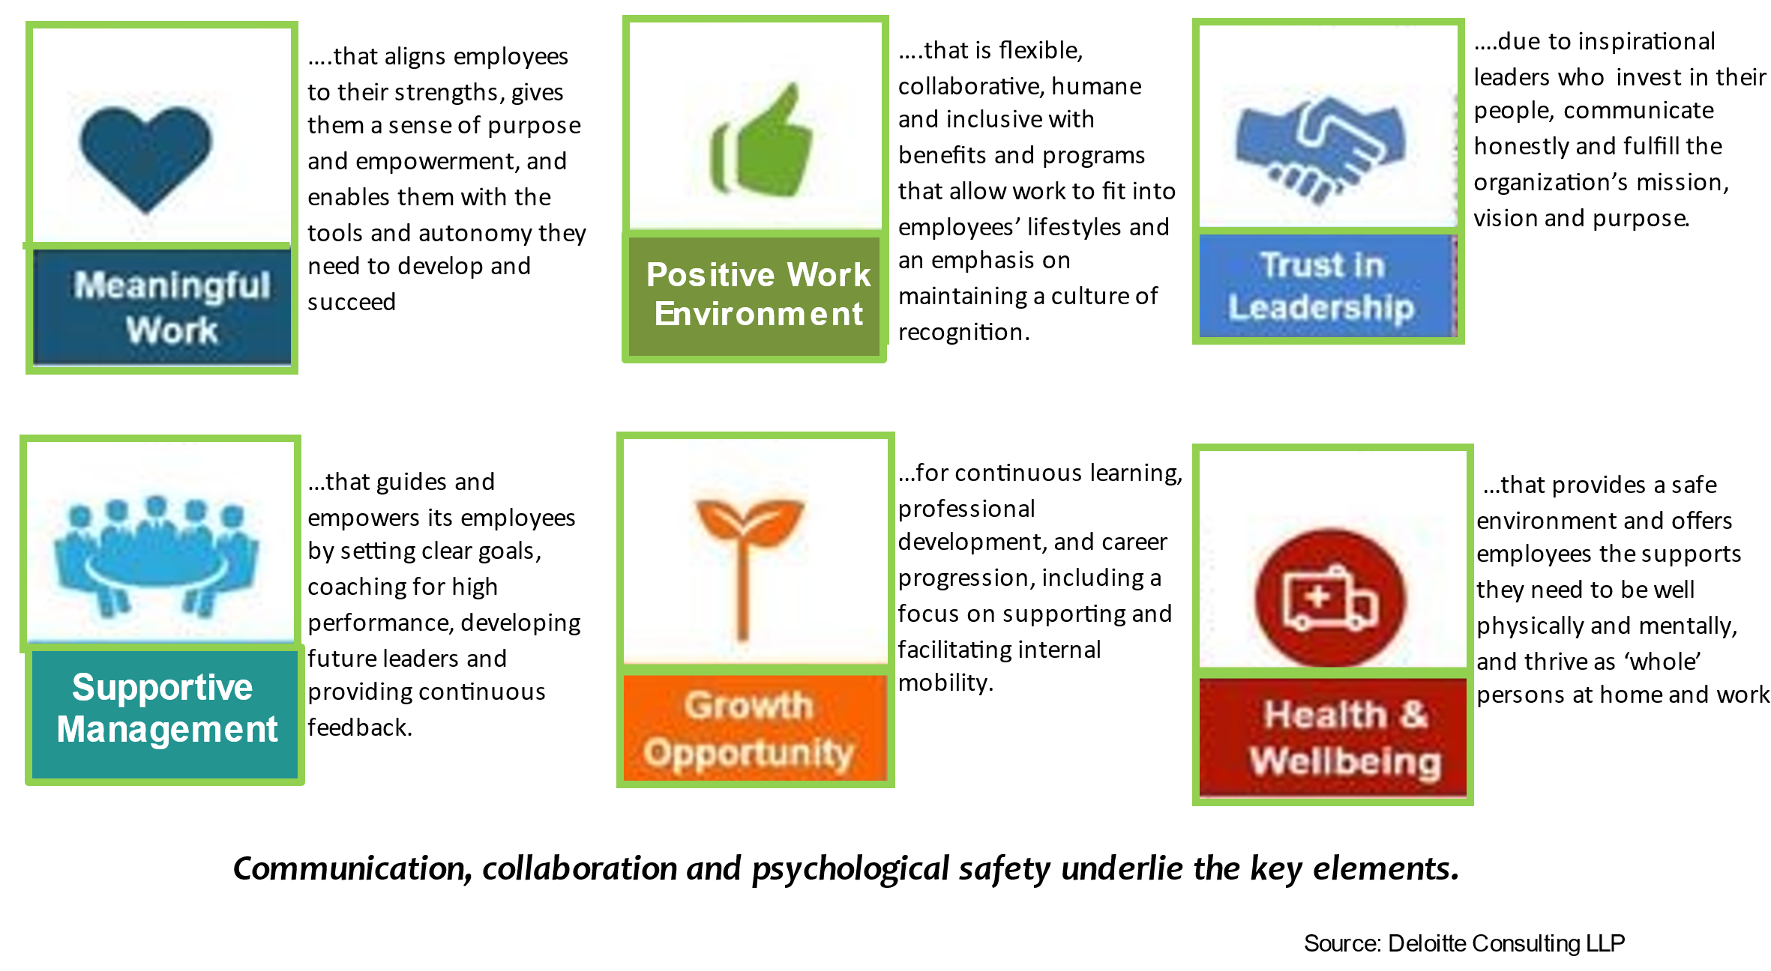

What leaders + managers can do to enhance retention
- Engage employees in the moment | - Support continuous feedback
- Remove employees’ top blocks | - Build trusting relationships
- Provide the tools needed to do the job | - Foster connection and inclusivity
- Stay ahead of technology | - Empower employees
- Communicate back to employees when action is taken | - Provide challenging assignments
- Provide pathways to promotion | - Show appreciation and acknowledge contributions.
- Assign a reasonable workload | - Connect their role to the organizational strategy

What are Undiscussables & What Do They Cost?

Undiscussables are things you think and feel on the job or in your personal life but won’t say. In a workplace situation, we are talking about things that are costing you money, both directly and indirectly. Our intent is to make you aware of the significant costs that Undiscussables represent.

We are not suggesting this as something that you must do or even need to do. The point of addressing Undiscussables is to empower you to make a choice about how you manage them when it is clear that the business cost outweighs being silent.

A company culture that feels safe and open enough to surface Undiscussables will have significantly more energy and time to focus on its priorities. It will also support the four core conditions of SMART Conversations® (dialogue): Shared Meaning, Authenticity, Respect and Trust.

Examples of Undiscussables

Hard costs

- You know that the materials you are using are below quality. Yet, you have a deadline hanging over your head. You choose to be silent about it.
- A team member is under performing. Everybody is aware of it, and you choose not to address it.
- Your project is over budget and/or behind schedule. You choose to be silent.

People costs

- You have a problematic relationship with your client, yet you choose to ignore it.
- Regarding #2 above… everybody knows that the person is not meeting expectations, and you are losing credibility.
- A senior person in the organization is disrespectful to team members, causing low morale. Yet, everyone remains silent.

How to Decide when to Surface an Undiscussable at Work

Value and Importance  Is the relationship valuable enough?  Is the task important enough? | Frequency and Pain  Is the crisis severe enough?  Is the contact frequent enough?  Is the discomfort intense enough?
Hard costs to the Business  Is the undiscussable…  Negatively impacting productivity?  Putting the company’s reputation at risk?  Putting your professional credibility at risk?  Creating a safety issue? | Risking a client relationship?  Creating project budget overruns?  Slowing the project down and leading to delays

Employee Retention Action Plan

Commitment | Description | Start Date
#1

#2

#3

