NSDCAM Partnering
Robert Brandon, robin Greenleaf
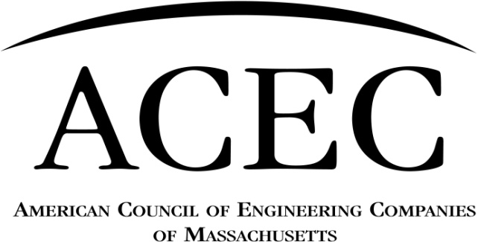

TECET Staff
Staff Liaisons:
AG = Abbie Goodman: 617/305-4112
ET = Elizabeth Tyminski: 617/305-4127
MJ = Meghan Jones: 617/305-4104

TECET Representatives
David Bohn
Bill Hadge
Ko Ishikura
Mike Scipione

ACEC/MA Executive Director;

TECET Chief of External Affairs

Abbie Goodman

Executive Committee
Dennis Baker
Scott Miller
Cynthia Joudrey
Colleen Moore, Robert Belitz
Jennifer Howe,
Abbie Goodman

ACEC Education Corporation (EC) Board
Jennifer Howe
Dennis Baker
Scott Miller
Cynthia Joudrey
Colleen Moore
Robert Belitz
Abbie Goodman

Counsel

David Hatem
BOARD OF DIRECTORS
Dennis Baker – President
Scott Miller – President-Elect
Cynthia Joudrey – Senior VP
Colleen Moore – Vice President
Jennifer Howe – Past President
Robert Belitz – Treasurer
John Doherty– Secretary
Lisa Brothers – National Director

Directors:
Dawn M. Connelly Gerry Preble
Jennifer Ducey Charlie Russo
Nick Ferzacca Jeffrey Tubbs
Madjid Lahlaf Kristine Wickham
Hillary Lacirignola Michael Cooper, ACEC ExCom
Madjid Lahlaf (Mitch Simpler, ACEC ExCom)
Colleen Moore – Director
Scott Miller – Director
(David Hatem, Legal CouMJel)
2020 – 2021
8-13-20 – updated

Events & Operations: Providing education & communications for Member Firms
Client Sector:
Focused on Improving Infrastructure & Streamlining Project Delivery for Clients & Member Firms
Business Group: Forums Focused on Business Operations Issues for Member Firms

Legislative & Advocacy: Focused on Advocacy for Member Firms

Accounting and Finance Forum
Board: Robert Belitz
Co- Chairs: Jackie Weir, Chad DaGraca
Staff: AG, MJ
Membership Committee
Board: Scott Miller
Co-Chairs: Dawn Connelly, Jeff Tubbs
Staff: AG, MJ
Awards Committee
Board:
Jen Ducey
Co-Chairs: Kurt Jelinek, Deborah Danik
Staff: ET, MJ

Transportation Agency Liaison Committee
Board: Kristine Wickham
Co-Chairs: Filomena Maybury and Dori Ross
Staff: AG, MJ

MBTA Partnering**
Janice Bergeron, Filomena Maybury
Massport Partnering
Ileen Gladstone & Emad Elsakka
MassDOT Highway Partnering
John Byatt, Rebecca Williamson
MassDOT Planning Partnering
Brian Vaillancourt, Kristine Wickham
Alternative Delivery Task Force
TBD
City of Boston Partnering PW**
On hold

RTAC
Frederick Moseley
Thomas Daley
Massport DSP

GreenDOT: Susan Nichols

Government Affairs Committee
Board: Dennis Baker
Chair Scott Miller
Vice Chair: Cynthia Joudrey Staff: AG, MJ
Water, Energy and Environmental Affairs Committee
Board: Bob Belitz
Co-Chairs: Kevin Walsh, Caroline Hampton, Johanna Hall
Staff: AG, MJ

DCR Partnering
Chad Cox, David LaPointe
MWRA Partnering
TBD
DEP Partnering

DEP Wastesite Cleanup Advisory Committee
Ileen Gladstone

Building Engineering Committee
Board: Nick Ferzacca
Co-Chairs:
Nick Ferzacca, Dan Tenney
Staff: AG, MJ

DCAMM Partnering (w/AIA/MA)
TBA
City of Boston Partnering Property & Construction Mgmt **
TBA
MSBA OPM Advisory Committee
Jean McCluskey
MSBA DSP
Leo Peters

Private Sector Committee
Board: Gerry Preble
Chair: Gerry Preble and Carol Dennison
Staff: AG, MJ

Human Resources Forum
Board: Colleen Moore
Co-Chairs: Lisa Dolan , Leila Cahillane, Staff: AG, MJ
Program Committee

Board: Colleen Moore
Co-Chairs: Dominic Rinaldi, Mike McDonough
Staff: AG, MJ
Communications Committee
Board: John Doherty
Co-Chairs: Allison Hopkins, Nicole Sparks Staff: AG, MJ

Legislative Advocates
Board: Rasky Partners, Inc.: Jeffrey Terrey
Molly Sullivan, Staff: AG

Information Systems Forum
Board: ______, Co-Chairs Andres Repetto,(Greg Bosworth/VHB team) Staff: AG, MJ

QBS Committee
Board: __________
Co-Chair: Scott Delesdernier, _______
Staff: AG, MJ
Fellows Committee
Board: Jennifer Howe
Chair: TBA
Staff: AG, MJ
Leadership Education Committee

Board: Hillary Lacirignola
Co-Chairs: Joanne Linowes, Ed Baumann
Staff: ET, MJ
Risk Management Forum
Board: Charlie Russo
Co-Chairs: Anne Leifer, Laurie Mahoney
Staff: AG, MJ

PAC Trustees
Lisa Brothers, Dennis Coffey, Robin Greenleaf
Staff: AG

STEM Outreach Task Force
Board: Nick Ferzacca
Co-Chair: Mike Scipione, Sam Taugher
Staff: AG, MJ
Health and Safety Forum
Board: Dawn Connelly
Co-Chairs: David Langlais, Steve Hawkins, Staff: AG, MJ
Diversity, Equity & Inclusion Task Force
Co-Chairs:, Hillary Lacirignola, Kristine Wickham, others
Staff: AG
** MBTA and City of Boston partnering groups are applicable to both TALC and the Building Engineering Committee

