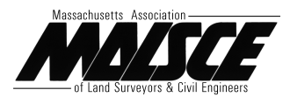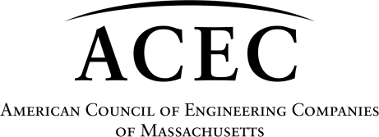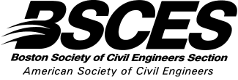

Massachusetts Transportation Infrastructure

INVESTING TODAY FOR CLIMATE RESILIENCY, CONGESTION REDUCTION AND OUR FUTURE
In addition to support for an increased state gas tax and more use of tolling, with revenues dedicated to transportation infrastructure, we support a pilot project for VMTs (Vehicle Miles Traveled).
And we support bills that help to provide:

Accessible, frequent, and fast public transit gets people to their destinations without contributing to traffic.

Connected, well-maintained, and extensive roads, trails, bike lanes, and sidewalks encourage active transportation, health, and recreation.

Making our entire transportation system safe, comfortable, and accessible for users of all ages, abilities, income, and travel modes leads to healthier and stronger communities.

We urge support for these bills:

TRANSPORTATION NETWORK COMPANIES
- SB2295- An Act to reduce congestion and encourage shared rides by Senator Brendan Crighton
- HB3523- An Act to reduce congestion and encourage shared rides by Senator Jay Livingstone
These bills codify a process for capturing increased value along transportation corridors for transit, roadway, and TOD development. This act would increase the current surcharge on Transportation Network Companies like Uber and Lyft, bringing Massachusetts into parity with other cities and states nationwide, and encourage shared trips in order to reduce traffic congestion and improve mobility.

VALUE CAPTURE
- HB3608- An Act relative to transportation infrastructure value capture by Representative William Straus
This bill allows for the increased land value created by a transportation project to be used to fund that project directly. This is a tool not currently available in Massachusetts, but it is one that is used all across the country to finance transportation investments.

REGIONAL TRANSPORTATION BALLOT INITIATIVES
- SB1899- An Act relative to regional transportation ballot initiatives by Senator Eric Lesser
- HB2978- An Act relative to regional transportation ballot initiatives by Representative Jack Patrick Lewis
These bills would enable a municipality, or a group of municipalities as a district, to raise additional local money for transportation projects, operations, or transit-oriented development via ballot initiatives. A supplement to other state and federal transportation revenue, these funds would give voters a more direct role in the process and show a clearer correlation between revenue and transportation projects. In states that allow these initiatives, there is an average 70-80% success rate.

LOCAL INFRASTRUCTURE DEVELOPMENT PROGRAM
- HB2135- An Act to improve the local infrastructure development program By Representative Christine Barber
- SB1337- An Act to improve the local infrastructure development program by Senator Adam Hinds
These bills amend an existing provision that allows property owners to finance public infrastructure improvements with tax-exempt bonds. This update reduces approval thresholds from their current level of 100%, allows for greater role for municipalities in the creation and management of districts, and clarifies language to ensure investments prioritize smart growth principles.

ACTIONS REQUESTED
- Support new revenue for transportation, including increased use of tolling, in conjunction with the other New England states or a pilot project for collecting fees on VMTs (Vehicle Miles Traveled.)

Continue to support the Financial Management Control Board as it works to improve business processes and develops a long-term plan for the T that efficiently uses its resources.
- Support a multiyear commitment of $300 M/year for Chapter 90 funding, enabling municipalities to do longer term planning for capital needs.

