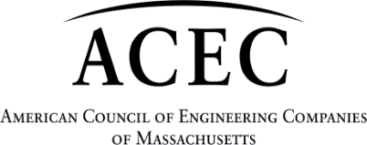




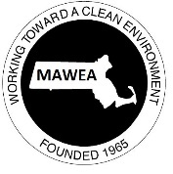
Water Infrastructure Investment Creates Jobs

Support HB 852, An Act relative to municipal assistance for clean water and economic development infrastructure (Rep. Jay Livingstone) – [In Study]

ISSUE:
The Commonwealth and its municipalities face an impending water crisis created by antiquated infrastructure, a failure to adequately invest in maintaining existing water and sewer infrastructure, and new unfunded regulatory mandates.

BACKGROUND:
Across the nation, cities and towns depend on water infrastructure to provide clean and reliable water for the protection of public health and safety while enhancing economic viability and overall quality of life. The million miles of water pipes below our streets represent an enormous public asset largely built and paid for by earlier generations. Aging and failing water and sewer infrastructure threaten public health and safety by degrading water quality and compromising fire protection through reduced flow.

Many Massachusetts communities have water and sewer systems that are well over 100 years old and are in dire need of rehabilitation and/or replacement. Leaking water pipes drive up treatment costs and increase the risk of breaks. Leaking sewer pipes allow groundwater infiltration, driving up wastewater treatment costs and negatively impacting groundwater levels. Many water/wastewater treatment plants were built in the 1970s (with federal funding) and now require significant upgrades that will cost millions. In addition, the US EPA Phase II Stormwater program requires many communities to develop plans to treat stormwater discharges, costing millions of dollars statewide. Safe and reliable drinking water and clean water bodies sustain our ecosystems, economy and recreational opportunities, and provide a quality of life that Massachusetts residents have come to expect.

Water and sewer rates are rising, but they are not able to keep pace with the needed investments. The Commonwealth needs to provide leadership and direction to ensure solutions are created to help communities and their respective water suppliers deal with this significant funding gap.

KEY POINTS:
- Much of the water infrastructure below our streets was constructed during three periods: the late 1800s, the roaring 1920s and during the post-World War II baby boom. The pipes from these different eras are wearing out now and will continue to wear out over the next three decades. There is a heightened emphasis on complete removal of Lead Service Lines to protect young children from the harmful effects of lead exposure.
- A 2012 report by the Massachusetts Water Infrastructure Finance Commission found that there is a significant gap between available funding and what is needed over the next 20 years to improve water-related infrastructure: $10.2 billion for drinking water; $11.2 billion for wastewater; conservative estimate of $18 billion for stormwater. These estimates do not consider more recent regulatory mandates to address Per- and Polyfluoroalkyl Substances (PFAS), Combined Sewer Overflows (CSOs), or removal of Lead Service Lines.
- A 2017 report by the State Auditor’s office recommended that “Given the continuing decline of overall state aid as a share of local budgets, the Legislature should expand the State Revolving Fund (SRF) as administered by the Clean Water Trust to provide full grants in addition to its current practices of low-interest loans and limited principal forgiveness for cities and towns undertaking water system repairs and enhancements.”
- On April 4, 2023, EPA released the 7th Drinking Water Infrastructure Needs Survey and Assessment (calendar year 2021), noting that Massachusetts water systems have $15 billion in need over the next 20 years for water infrastructure projects to continue providing safe drinking water to the public (not taking into account compliance with the updated PFAS standard).
- A report issued at the US Conference of Mayors (2008) states that every dollar invested in water infrastructure services returns $8.97 to the national economy.
- 28,500 jobs are created for every $1 billion spent on water infrastructure investment. (US Conference of Mayors, others).
- Funding available through the once-in-a-generation Bipartisan Infrastructure Law (BIL) and the American Rescue Plan Act (ARPA), while welcome and appreciated, will not be near enough to bridge the gap on our water infrastructure funding needs.

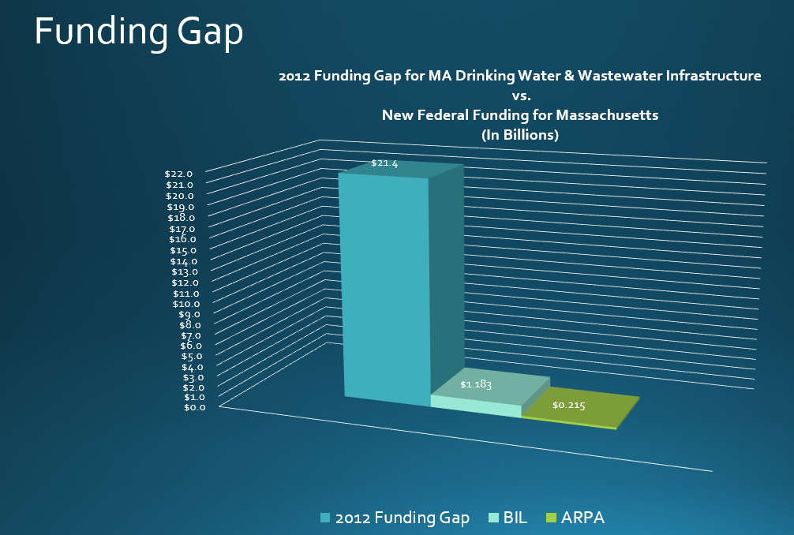

- The primary mechanism for funding water infrastructure projects is the State Revolving Fund, administered by the Clean Water Trust. Most of the BIL water infrastructure funding will be distributed through this process. The State Revolving Fund is a competitive loan program which may offer favorable incentives for certain communities in the form of lower interest rates or principal forgiveness, but primarily will need to be paid back by ratepayers. Many critical water infrastructure projects are not scoring high enough against higher priority PFAS projects to even access this funding.

ACTIONS REQUESTED:
- We respectfully ask the legislature to support increased funding for water infrastructure, including HB 852, An Act relative to municipal assistance for clean water and economic development infrastructure.
- Chapter 259 of the Acts of 2014 raised the state capitalization of the SRF program from $88 million to $138 million, but the legislature needs to appropriate the funding. The Act also provides access to less than 2% loans, 0% or even principal forgiveness if a project meets certain criteria. Please fully fund capitalization at $138 million.

