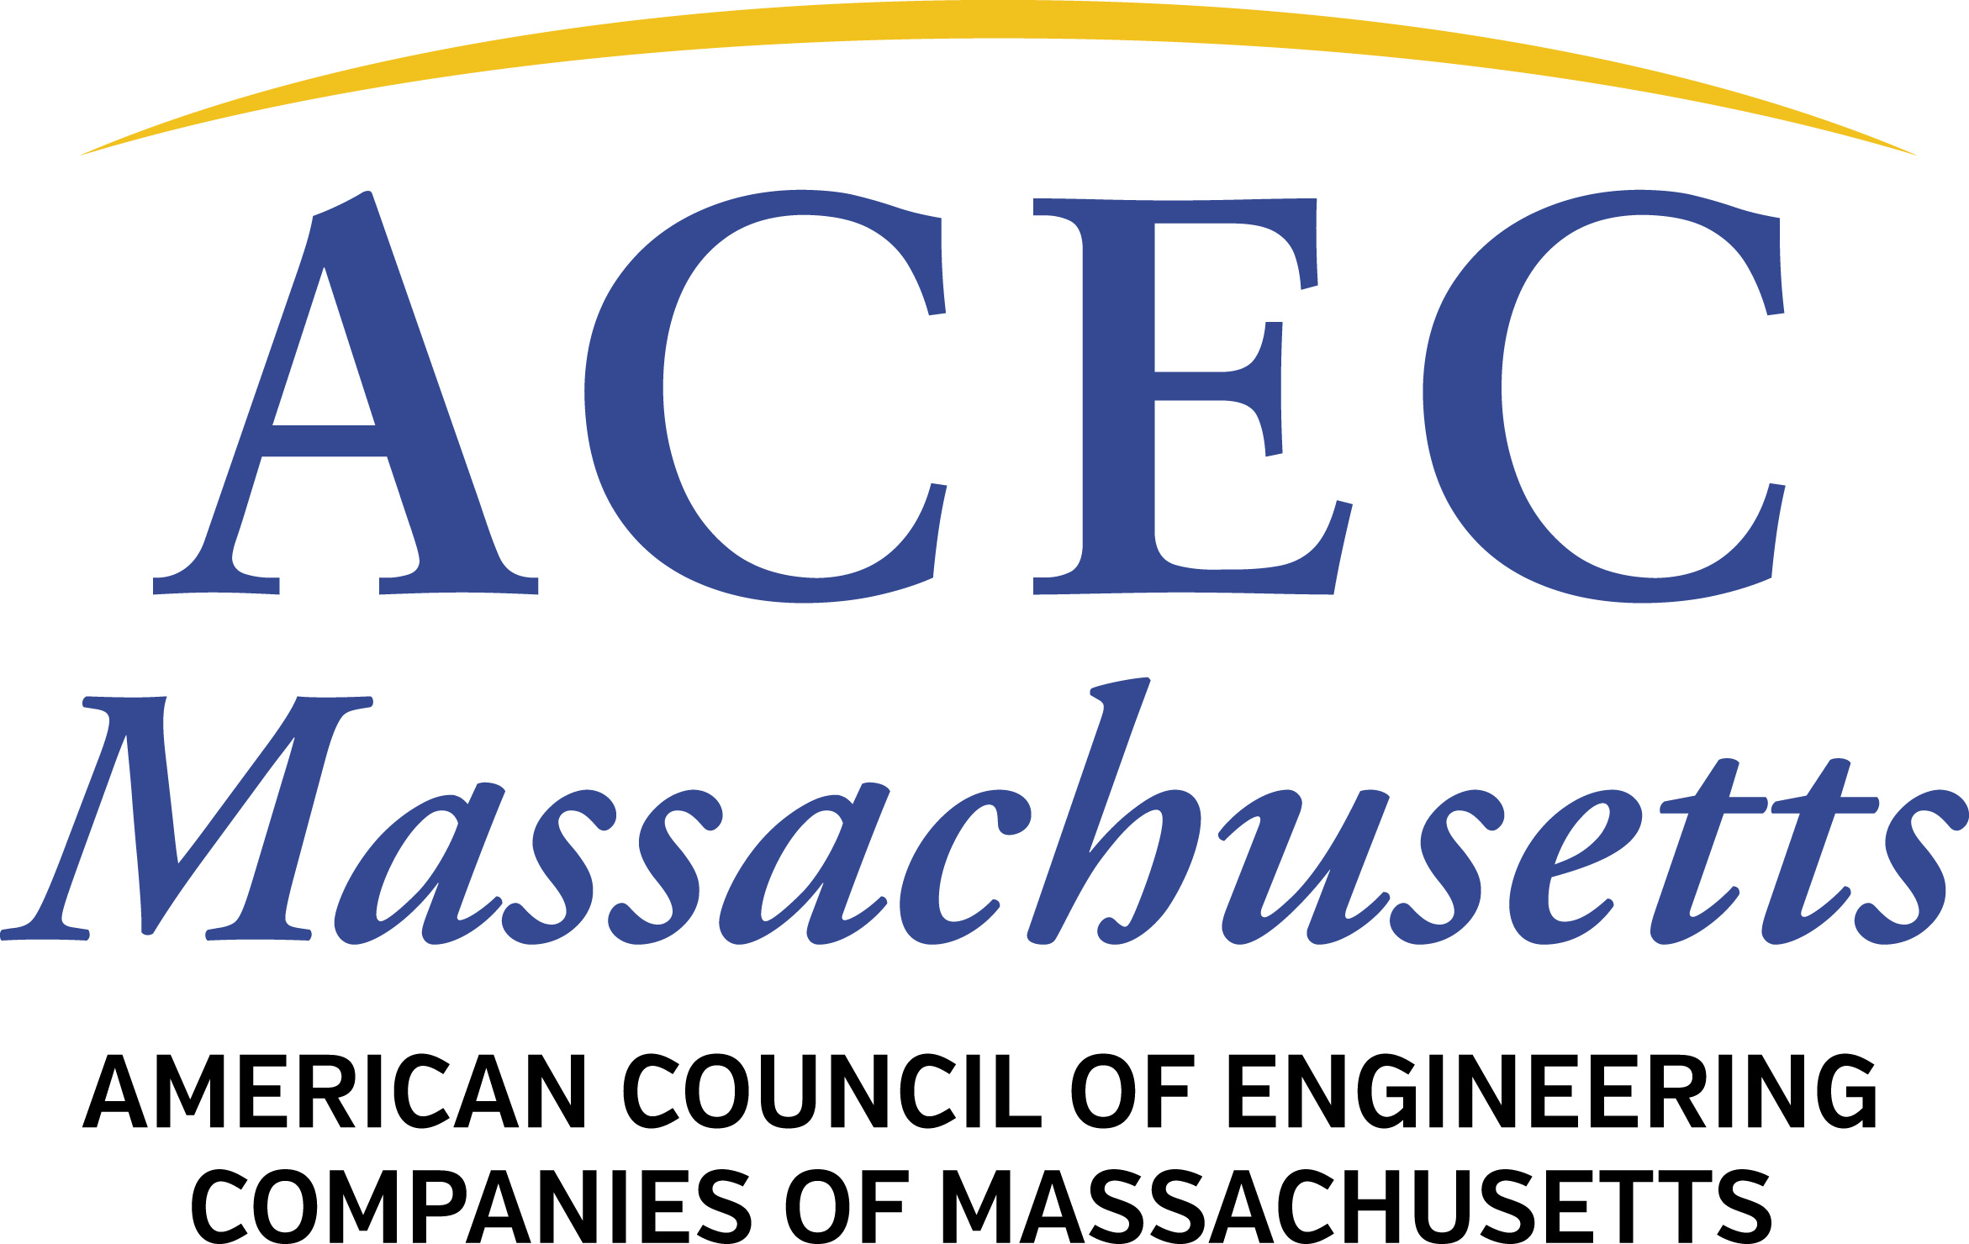

2019 National Qualifications-Based Selection Awards
Call For Nominations
ACEC/MA Deadline: July 19, 2019 @ 11 AM

ACEC/MA is seeking Nominations for the 2019 QBS Award. Nominations must be submitted to acecma@engineers.org and agoodman@engineers.org by 11 AM on Friday, July 19.

If ACEC/MA selects a nominee for this national competition, the client public agency will be recognized at the spring 2020 ACEC/MA Engineering Excellence and Awards Gala and the nomination will be submitted to ACEC National and NSPE

Every year, ACEC and NSPE partner to administer the QBS Awards, recognizing public and private entities that make exemplary use of the Qualifications-Based Selection process at the federal, state and local levels. QBS Award winners serve as examples of how well the QBS process works, and they help ACEC and NSPE promote the practice of QBS in jurisdictions that do not use, or underuse, QBS to procure engineering services.

ACEC and NSPE are now seeking nominations for the 2019 QBS Awards. The ACEC/MA deadline for nominations is Friday, July 19, 2019 at 11 AM. A nomination form is attached for your use.

Three QBS Awards
A maximum of one QBS Award may be presented in each of the following categories:

- Federal Government Sector
- State Government Sector
- Nongovernment Sector

ACEC/MA will work with MSPE on this: Each nomination shall require, before submission, the signed endorsement of both the ACEC Member Organization and the NSPE State Society of the nominee’s state or region. Nominations submitted that do not meet this requirement shall be returned for the necessary endorsements, and if such are not forthcoming, the nomination shall be disqualified.

Governmental entities eligible for nomination include, but are not limited to, federal governmental departments or agencies, state governmental departments or agencies, municipalities, local governments, school districts, university systems, public utility systems, publicly funded research laboratories, and special purpose districts.

Nongovernmental entities and individuals eligible for nomination include, but are not limited to, private corporations, privately funded research labs, private utility companies, design professionals, construction contractors, developers, and any nongovernmental entity that uses design professionals’ services on a regular basis.

Mandated and Non-Mandated QBS
Public entities operating under mandated QBS procedures (the federal Brooks Act or state “mini-Brooks laws”) are eligible to receive the QBS Award if they have demonstrated exceptional leadership in using Qualifications-Based Selection. However, nominations for public entities that use QBS where no legal mandate applies will receive priority consideration if all other criteria are rated equally.

Evaluation Criteria
Evaluation criteria for the QBS Award may include the following elements, depending on their relevance to the agency’s program and process:

- Market Survey, including performing a market survey and publicizing the results of the survey prior to the RFQ.
- Public Notice, including the use of pre-solicitation notices, allowing a reasonable number of firms to submit qualifications, and sufficient pubic notice to allow for research and teaming actions.
- Request for Qualifications (RFQ), including the level of detail in the RFQ describing the professional services requested, clarity in the scoring criteria used in evaluating responses, the response requirements (appropriate submittal length, past performance and reference information requirements), and the duration provided to prepare responses to the RFQ.
- Evaluation Methodology, including the implementation of standardized scoring correlated to the requirements stated in the RFQ, appropriateness of selection board configuration, timeliness of the selection and notification of both selected and non-selected offerors, and use of references in the evaluation.
- Interview (if applicable), including an appropriate number of firms shortlisted for interviews, suitability of the interview content and structure for the project, standardization of interview format and questions, providing reasonable notice of the interview schedule, and prompt notification of results.
- Debriefings, including providing useful and adequate feedback in a timely manner to all submitters.
- Negotiations, including whether negotiations were performed in timely manner and in good faith.

Recognition at the 2019 ACEC Fall Conference
The QBS Award winner will have an opportunity to receive a trophy and to be recognized during the ACEC Fall Conference in October 2019 at the Sheraton Grand Chicago. Travel and lodging expenses will be reimbursed by ACEC, subject to ACEC’s policies and as permitted by law.

In addition to the QBS Awards, this program generally designates up to four QBS Merit Award winners, who will each be presented with a plaque at a state-level event.

Program Coordination Between ACEC and NSPE
Since the QBS Awards is a joint awards program, coordination between the appropriate ACEC and NSPE state organizations is critical. Therefore ACEC/MA will seek support of this nomination from MSPE.:

- NOTE: Please confirm your nominee’s consent for award consideration.

Public and private entities that employ a two-envelope procurement process or that include fees or rates in the determination of the most highly qualified respondent are not eligible for consideration under this awards program.

If you have any questions, please contact Abbie Goodman at agoodman@engineers.org

Thank you for your interest in Qualifications-Based Selection.

Attachment: Nomination Form

NOMINATION FOR THE 2019 ACEC/Massachusetts Nominee for the ACEC/NSPE QBS AWARD
FOR DESIGN PROFESSIONAL PROCUREMENT PRACTICES

PLEASE CONFIRM your nominee’S CONSENT FOR AWARD CONSIDERATION BEFORE SUBMITTING THIS FORM.

Electronic Completed Nomination Forms should be sent to ACEC/MA: acecma@engineers.org and agoodman@engineers.org .

PUBLIC AND PRIVATE ENTITIES THAT EMPLOY A TWO-ENVELOPE PROCUREMENT PROCESS or that include fees or rates in the determination of THE most highly qualified respondEnt ARE NOT ELIGIBLE FOR CONSIDERATION UNDER this AWARDS PROGRAM

DEADLINE: 7/19/2019, 11 AM to acecma@engineers.org and agoodman@engineers.org

1. Candidate:

Category:

_____Federal Governmental
_____State Governmental
_____Nongovernmental

2. Key Candidate Contact:

Title:

Address: _______________________________________________________________

City, State, & Zip Code:

Telephone:

E-mail:

3. Nominated by:

Affiliation: ______________________________________________________________

Address:

City, State, & Zip Code:

Telephone:

E-mail:

Endorsed by:

_________________________________
On Behalf of ACEC Member Organization

_________________________________
On Behalf of NSPE State Society
ACEC.MA will collect this

4. Did a QBS facilitator meet with the candidate? Yes No

QBS facilitators are individuals who provide education to public owners on the merits of using QBS to procure design professional services, and provide assistance on implementing a qualifications-based A/E selection process.

Name of QBS facilitator: ______________________________________

5. Please provide a brief narrative explaining why this public entity/private entity/individual is a candidate for a QBS Award:

6. Describe the nominee's selection procedure:

7. Is the procedure a written policy? Yes No ___
(If yes, please include a copy of the policy.)

8. How long has the selection process been used?

9. Does the process cover: Architects Engineers Land Surveyors

10. Who administers the selection procedure?

11. Is the administrator a: PE AIA PLS Other

12. Who makes the final decision on which design professional is chosen?

13. Is QBS government-mandated? Yes No

14. Additional comments:

Signature, name, and affiliation of person submitting this nomination:

Signature__________________________________________________________________

Name ____________________________________________________________________

Affiliation__________________________________________________________________
PLEASE EMAIL TO: agoodman@engineers.org and acecma@engineers.org

