2023-2024

Society Sponsors

AECOM

Keller

Kleinfelder

2023-2024

Program Sponsors

Beals and Thomas, Inc.

Benesch

BETA Group

CDM Smith

CHA Consulting, Inc.

Collins Engineers, Inc.

Dewberry

GEI Consultants

Geocomp, Inc.

Green International Affiliates, Inc.

GZA GeoEnvironmental, Inc.

Haley & Aldrich, Inc.

HNTB

Howard Stein Hudson

Nitsch Engineering

Department of Civil and Environmental Engineering, Northeastern University

Simpson Gumpertz & Heger

Skanska USA Civil

Stantec

Tighe & Bond

TranSystems

TREVIICOS

Tufts University - Dept. of Civil and Environmental Engineering

Vanasse & Associates, Inc.

VHB

Weston & Sampson

WSP USA

Group Name

(TECET staff will delete group name and Insert logo)

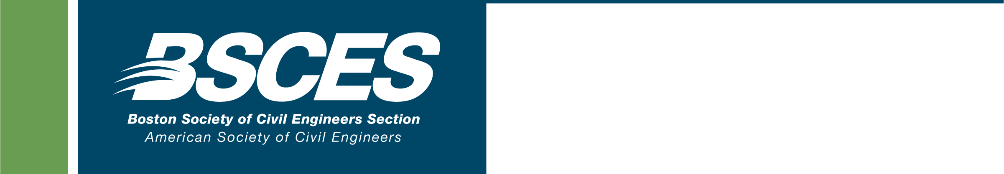

Title of Presentation

### Speaker’s Full Name, Credentials

*Speaker’s Title, Organization*

# **Date (Day, Month, Date, Year)**

**Address (Venue, Street Address, City, State)**

**Times (Social/Registration; Meal; Presentation)**

Presentation description

##### Registration Deadline: (Day, Month, Date, Year)

**Registration Fees (Members, Non-Members)**

**(Public Sector Members, Public Sector Non-Members)**

**(Senior Members (65+), Students)**

**Information/Registration:**Register to attend this meeting and pay by credit card online here (TECET Staff will insert link). To register online for an event at the BSCES member rate you must login using your BSCES assigned username and password. If you do not know your BSCES member login information call 617/227-5551. You can also register for this event by mail or email. To do so, download and complete a BSCES Event Registration Form and follow the submission instructions. Cancellations received after (Registration Deadline Month, Date, Year) and no-shows will be billed.



**This presentation provides (Insert number of PDHs) Professional Development Hours (PDH)**

Supported by the staff of The Engineering Center Education Trust

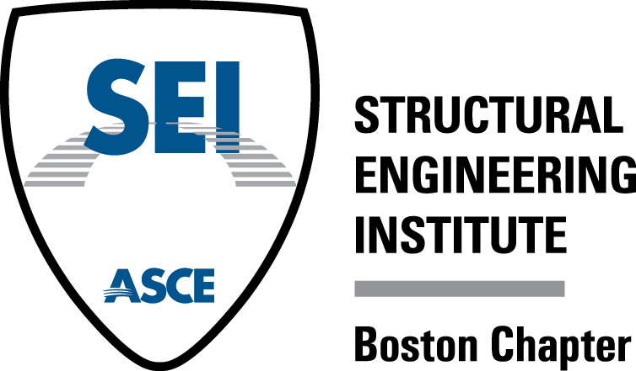

Supported by the staff of The Engineering Center Education Trust

*Doing Business with Massport*

### Sam Sleiman, PE, CCM, FCMAA, NAC

*Director, Capital Programs & Environmental Affairs*

*Massachusetts Port Authority*

# **Wednesday, May 20, 2020**

**Wyndham Boston Beacon Hill, 5 Blossom Street, Boston, MA 02114**

**6:00 PM Registration, Social & Dinner, 7:15 PM Presentation**

The Massachusetts Port Authority’s (Massport) Department of Capital Programs and Environmental Affairs (CP&EA) programs and implements Massport’s infrastructure and capital improvements. Among their wide-ranging responsibilities, CP&EA provides project and contract management, and technical expertise in engineering and architectural design and construction.

Mr. Sleiman’s presentation will provide an overview of current and upcoming Massport strategic projects, their consultant and construction selection process, make-up of their typical design and engineering teams, and Massport’s major initiatives, procedures and expectations for the delivery of a successful project.

##### Registration Deadline: Friday, May 15, 2020

**$100 Members, $125 Non-Members**

**$85 Public Sector Members, $100 Public Sector Non-Members**

**$35 Senior Members (65+), Students**

**$1,000 Table of 10**

**Information/Registration:**Register to attend this meeting and pay by credit card online at <http://bit.ly/2HqBrYw>. To register online for an event at the BSCES member rate you must login using your BSCES assigned username and password. If you do not know your BSCES member login information call 617/227-5551. You can also register for this event by mail or email. To do so, download and complete a [BSCES Event Registration Form](https://files.engineers.org/file/BSCESEventRegForm-Online.pdf) and follow the submission instructions. Cancellations received after May 15, 2020 and no-shows will be billed.

2021-2022

Society Sponsors

AECOM

Helical Drilling

J.S. Held

Keller

Stantec

2021-2022

Program Sponsors

Alfred Benesch & Company

BETA Group

BSC Group

CDM Smith

Collins Engineers, Inc.

Dewberry

Green International Affiliates, Inc.

GZA GeoEnvironmental, Inc.

Haley & Aldrich, Inc.

Horsley Witten Group, Inc.

Howard Stein Hudson

Hoyle, Tanner &

Associates, Inc.

HNTB

Kleinfelder

Nitsch Engineering

Civil and Environmental Engineering Department, Northeastern University

Patrick Engineering, Inc.

Sanborn Head &

Associates Inc.

Simpson Gumpertz & Heger

Skanska USA Civil

Tighe & Bond

TranSystems

TREVIICOS

Tufts University - Dept. of Civil and Environmental Engineering

VHB

Weston & Sampson

WSP USA