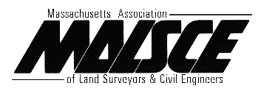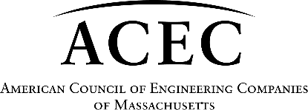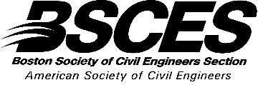

Wipes Regulations can Save Ratepayers $

Keep Waters Clean

S. 529, An Act protecting water systems through the labeling of flushable wipes.
Sponsor: Senator James B. Eldridge, Referred to Joint Committee on Environment, Natural Resources and Agriculture
H.897, An Act protecting water systems through the labeling of flushable wipes
Sponsor: Representative Carolyn Dykema, Referred to Joint Committee on Environment, Natural Resources and Agriculture
ISSUE
Massachusetts sewers face avoidable costs for clogs, fouled pumps and resulting sanitary sewer overflows. As the popularity of various wipes increases and users flush them, these costs will increase. During the COVID-19 pandemic, the use of wipes increased greatly, causing dangerous clogs and public health issues for sewer systems.

Since the early 2000s, wipes have been aggressively marketed as a replacement for toilet paper, mops, cleaning brushes and rags. This multi-billion-dollar industry[1] has had disastrous impacts on local sewer systems as clogs and fouled pumps increase.

KEY POINTS
This legislation targets only wipes and other products that are not flushable according to industry.
- Unlike toilet paper, wipes are not “dispersible” in normal sewer conditions
- Many such products are labeled “flushable”
- Clogs and fouling from flushed wipes costs sewer operations in Massachusetts nearly $10 million annually.
- In MA, the estimate just for operations is nearly $10M annually.
- NACWA (the National Association of Clean Water Agencies) promotes using science-based standards for dispersibility[2]
- Wipes should be properly and clearly labeled.[3]

ACTION REQUESTED
- We respectfully ask that the Legislature pass these bills to classify wipes, using wipes-industry standards as “non-flushable.”
- We ask that those wipes that do not meet industry dispersible standards have prominent, mandatory “Do Not Flush” labelling, following NACWA labeling guidelines.
These bills include strong, specific language[4].

________________________________________
[1] “One report from a product development company estimated the global market for these nonwoven wipes of all kinds to be $16.6 billion in 2018, with a growth rate of 5.7% a year, which would push the total to nearly $22B by 2023” (https://undark.org/2019/12/23/flushable-wipes/)
[2] The International Water Services Flushability Group (IWSFG) has specifications.
[3] 2nd Edition INDA/EDANA Code of Practice: Communicating Appropriate disposal pathways for nonwoven wipes. (INDA= the Association of the Nonwoven Fabrics Industry; EDANA = European Disposables and Nonwoven Association)
[4]Model legislation is available through NACWA and the Wastewater Advisory Committee to the MWRA

In addition to the associations listed above, these associations and organizations support these bills:

MAWEA, Massachusetts Water Environment Association
MMA, Massachusetts Municipal Association
MWRA Advisory Board
WAC, Wastewater Advisory Committee to the MWRA
WSCAC, Water Supply Citizens Advisory Committee to the MWRA
NEWEA, New England Water Environment Association
Yankee Onsite Wastewater Association

